**Dr. B. Vasantharaj David Foundation**

76/2A Sree Ramulu street, Madanandapuram, 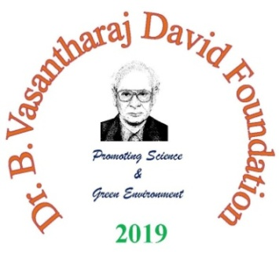

Chennai 600 125

Mobile 98401 64099,

Email ID. [davidfoundation2019@gmail.com](mailto:davidfoundation2019@gmail.com)

Trust Regn. No. 137/2019.

Website bvdfoundation.com

**NOMINATION FORM**

Excellence Awards – 2023

|  |  |
| --- | --- |
| Category Number |  |
| Discipline & Activity |  |

I would like to submit my nomination* for the Dr. B. Vasantharaj David Foundation **Excellence Awards – 2023.**:

Name:

Institution:

Address:

City: Pincode: State:

Mobile:

E-mail:

**Mention age as on 30th June 2023** (Enclose date of birth certificate): year – month - days

I have also applied for: Oral presentation / Poster presentation

Applied only for Excellence award: Mention details:

Details of payment of registration fee:

DECLARATION

I, Mr./Ms./Dr./Prof./ ……………………………….. hereby assure that the information provided is true to the best of my knowledge. False declaration will end up in surrendering my award to the Foundation. I will not hold the foundation responsible for any legal issue arises later for whatsoever reason. The work submitted is original work.

Date: Signature of the Applicant

Place:

If nomination submitted through Institute:

Signature of Forwarding officer with seal